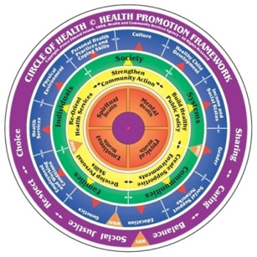

**Program/Initiative**

**Strategy: Build Healthy Public Policy**

**Activities:**

**Strategy: Create Supportive Environments**

**Activities:**

**Strategy: Develop Personal Skills**

**Activities:**

**Strategies -** How can we improve the situation?

**Strategy: Strengthening Community Action**

**Activities:**

**Strategy: Reorient Health Services**

**Activities:**

**Who is affected by the situation?**

**Who can help us improve the situation?**

**Populations -** Who do we work with to improve the situation?

**Determinants of Health -** On what could we take action to improve the situation?

**Values** Why take this action? What is motivating us?

**Goal**

**Issue/Needs**

Planning template developed by Eastern Health in NL and Adapted by Hastings Prince Edward Public Health for the Healthy Communities Partnership of HPE.